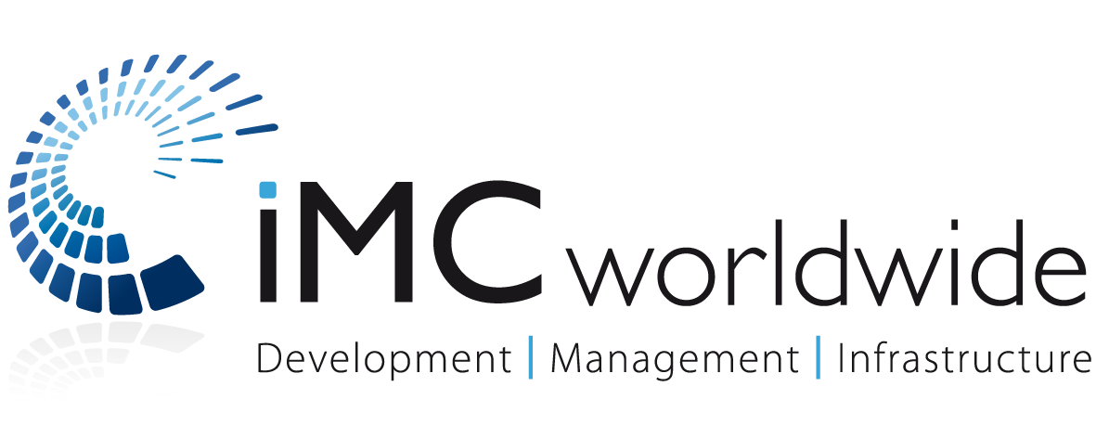
VAWG Mainstreaming: A Framework for Action
Dr. Janet Gruber, Dr. Tamsin Bradley, Kate Conroy
VAWG Mainstreaming: A Framework for Action

Report written by:
Dr. Janet Gruber
Dr. Tamsin Bradley (University of Portsmouth)
Kate Conroy
Table of Contents
List of Acronyms iii
Introduction 1
Building the Evidence Base: Why is a VAWG Mainstreaming Framework Necessary? 1
Stage One - Framing Knowledge Collection around VAWG to Guide Programme Design 2
With this knowledge in place 3
Stage Two - Operationalising Knowledge on VAWG: Designing the Programme 4
Stage Three - Implementing & Monitoring Change: Embedding a VAWG Lens at all stages 5
1. Creating an enabling environment to support action against VAWG, including policy and legal change and increased spending. 5
2. Changes to social norms that limit women and girls' opportunities to participate in society free from fear of VAWG. 6
3. Increasing social perceptions of the benefits and value of girls and women being equal partners in societies free from VAWG. 6
The VAWG Mainstreaming Framework feeds into the following sequence of theories: 7
Final Comments 8

List of Acronyms

ATJ | Access to Justice
DFID | Department for International Development
SDGs | Sustainable Development Goals
VAWG | Violence Against Women and Girls

Introduction
The growing international agenda and focus on improving gender equality and outcomes has recently been enshrined in Sustainable Development Goals (SDGs), with SDG 5 seeking to '(a) achieve gender equality and empower all women and girls'. Embedded within SDG 5 are nine targets whose common objective is to end gender inequality in all its forms. Specific focus on decreasing violence against women and girls (VAWG) is found within target 5.2 (eliminate all forms of violence against all women and girls) and 5.3 (eliminate all harmful practices). While positive that these intentions are clearly spelt out this does not guarantee that policies and programmes will be framed at least in part to meet these targets or what roadmap is needed to achieve these results. In order for Targets 5.2 and 5.3 to be achieved a clear stepped approach is needed to support stakeholders through the process of embedding a VAWG dimension in their programmes.
If we are to achieve an end to VAWG then this commitment needs to be embedded into all development programmes regardless of sectorial focus. Women and girls are vulnerable across the board, across sectors and all areas of development and recognition of this reality is the first step. While the framework we provide below focuses on centralising a VAWG lens into access to justice (ATJ) programmes it could, in fact, be used to guide a VAWG approach regardless of intervention focus.
While there are many examples of programmes, polices and conventions to end VAWG, we argue that without a systematic model for mainstreaming an end to VAWG we will not see SDG 5 and its targets achieved.

Building the Evidence Base: Why is a VAWG Mainstreaming Framework Necessary?
More attention is needed on building the case as to why a VAWG lens is so important across the development sector and in ATJ programmes in particular. For those actors who have deliberately positioned themselves as champions committed to ending VAWG the necessity for such deliberate action is obvious. However, it is not widely accepted across sectors that ending VAWG is both urgent and can act as a catalyst opening up pathways to enhancing wellbeing and justice across vulnerable groups (not just women and girls).
There is no agreed, commonly applied approach to mainstreaming VAWG prevention into sectorial and multi-sectoral programmes addressing aspects of ATJ. Such action can be aided by building partly on best practice, lessons learned and indeed some of failures of gender mainstreaming. The development of an evidence base to inform future action is crucial; one such example is the DFID-funded What Works to Prevent Violence Against Women and Girls global research initiative. Gathering rigours evidence that supports a drive to embed a VAWG perspective into ATJ (and other) programmes is a critical first step.

Stage One - Framing Knowledge Collection around VAWG to Guide Programme Design
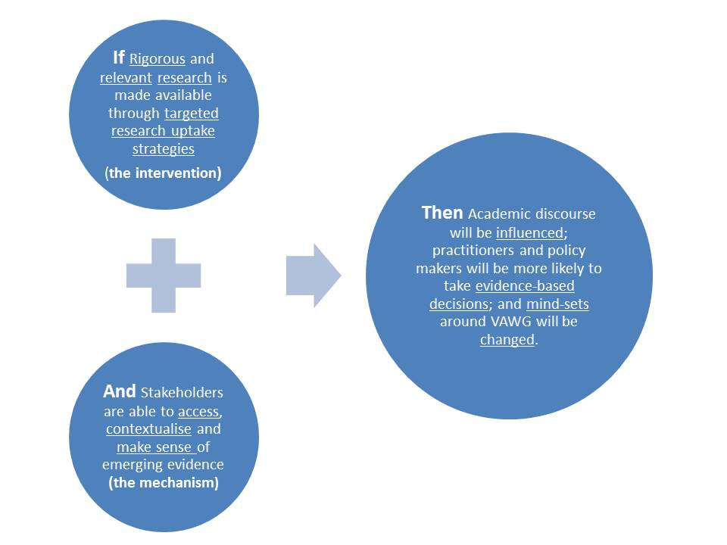
A VAWG lens requires actors to automatically reflect on how and if a programme will positively or negatively impact on VAWG. A series of critical and reflective questions should be asked through the design stage that considers if and how interventions may positively or negative impact on levels of VAWG. These include:
Design Questions | Programme Reflection
- Do we understand the types of violence most commonly experienced by women and girls programme recipients?  - To what extent are these types of violence commonly talked about and acknowledged to be unjust and abusive? What level of normalisation exists?  - To what extent is this normalisation of violence similarly applied by men and women, boys and girls? | Understanding these types of violence should involve an understanding of the contexts in which it occurs (at home, school, work on the way to school or work etc.) If this is not known should a piece of research be commissioned in order to gather this knowledge?
- Are some groups more likely to project normalised views of VAWG?  - Who are the most vulnerable groups?  - And what material resources and/or social/cultural capital do they have to draw on? | Similarly an exercise to map out what resources and forms of social and cultural capital already exist (e.g. through established community groups) is needed in advance of programme design. Projects should build where ever possible on tried and tested approaches so as to minimise the risk of triggering a backlash (and therefore potentially increasing the vulnerability of certain groups).
- What internal differences scan be seen in patterns and types of violence and in the triggers for it? In other words are certain forms of VAWG more common in particular areas and under certain conditions? | Can a one size fits all approach to programming respond to the complex contexts of VAWG even in one country? To what extent will a more locally tailored response be necessary and if so is this feasible?

With this knowledge in place
In other words the starting point is understanding the experiences of vulnerable groups (e.g. women and girls) and working outwards into the environment and contexts in which they live and asking; what can the programme do to end the violence they suffer?
Building this knowledge can be supported through a theoretical approach knowledge as The Ecological Model (see Figure 1 below).

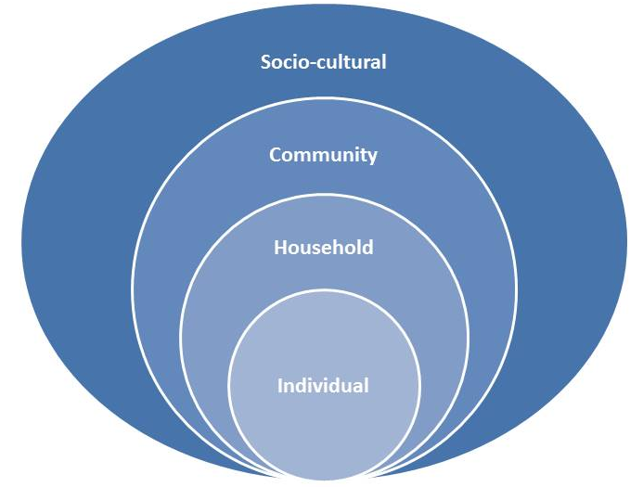
Figure 1 - Ecological Model
This model supports an outward approach that begins with the experiences of individuals. However it is understood that these personal experiences are in fact triggered by dynamics (largely gendered) occurring at the household level, which in turn is shaped by community structures and then wider socio-cultural beliefs and values.
In particular it surfaces the ways in which decisions are made, who has the power to decide what they can and can’t do with their life? Who has the most access to the recourses, such as food, but also medicines and luxury goods? It also leads to a reflection on what happens when individuals challenge these power structures? Is violence used to discipline and maintain this status quo? Is it used to remind household members of the hierarchy of power? How are these structures and behaviours shaped by worldviews that hold to a status quo that marginalises some and in doing so creates groups who are vulnerable because they have less power?

Stage Two - Operationalising Knowledge on VAWG: Designing the Programme
The ecological model could be used to steer questions specific to the goals of programmes, for example in relation to ATJ programming it might look like this:

Social Ecology Level | Meta-Question | Factors to think about for Operationalisation
Socio-cultural | - What cultural practices and common views exist in regard to women and girls and specifically the use of violence against them? | Are there views emerging that need to be captured, challenged and changed by the programme?
Community | - What community mechanisms exist to mitigate VAWG or offer security and protect to victims? | How effective are the community mechanisms perceived to be and could they be built upon by the programme?
Household | - What dynamics exist at household level that my support or perpetuate VAWG? | Are there certain intra-/inter- household behaviours that need to be challenged by the programme? Is there opportunity to use the programme to tap into certain change dynamics (e.g. is there evidence that young educated women challenge their parents about the use of violence?). Can they be supported by the programme?
Individual | - What room is there for individuals to challenge and change social norms surrounding VAWG? | Can individuals who may be in the minority but wish to see VAWG end tap into wider networks and support structures to mobilise the change they want to see? If the answer is yes can the programme build on them? If it is no can the programme in fact build them?

Stage Three - Implementing & Monitoring Change: Embedding a VAWG Lens at all stages
Building on the knowledge gained through the first two stages a three dimensional VAWG lens could be used to implement, shape, monitor and adapt a programme. The proposed dimensional framework develops or operationalises the ecological model used in Stage 2 to help develop detailed contextual knowledge around why and how VAWG materialises and flourishes. It consists of: an enabling environment, social norm change and positive social perceptions of the benefits of girls and women.
These dimensions represents the spaces and areas where change most needs to happen if VAWG is to end and then be prevented moving forward. In both the design, implementation, monitoring and programme adjustment questions should be asked in relation dimension.

Creating an enabling environment to support action against VAWG, including policy and legal change and increased spending.
Programmes will need to address any lack of process, system, and resources (human and material) in relation to the spheres that make up this environment (Government, Legal, Police, Social/Psychological support (including safe houses), medical (forensics and treatment).
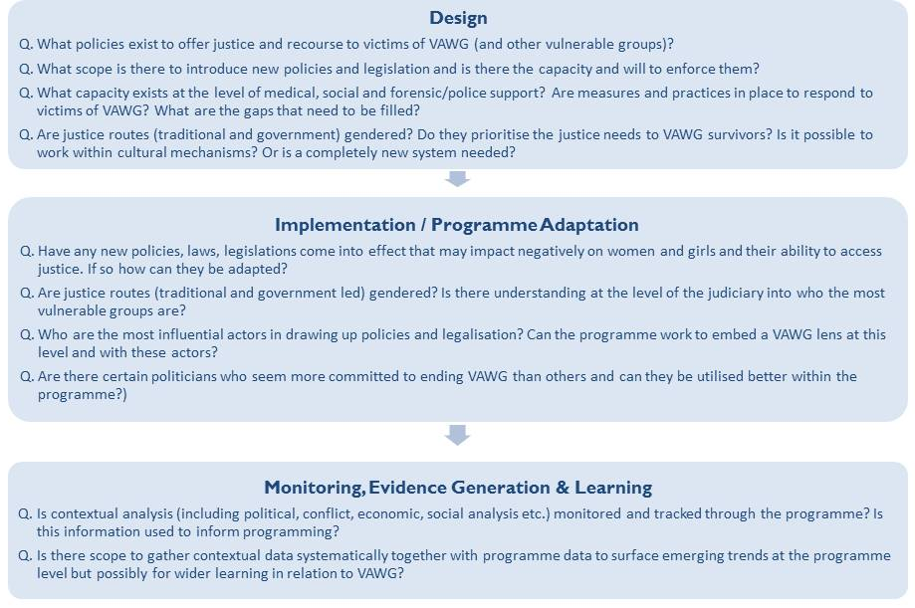

Changes to social norms that limit women and girls' opportunities to participate in society free from fear of VAWG.
The ecological model can be used to draw out in-country differences and to guide understanding of what kind of social norm change interventions might be appropriate – particularly in relation to social norms. Testing of innovative new interventions, and trialling of programmes that have worked elsewhere all need to be implemented with caution and close monitoring: there are no quick solutions and what works in one context will not in another.
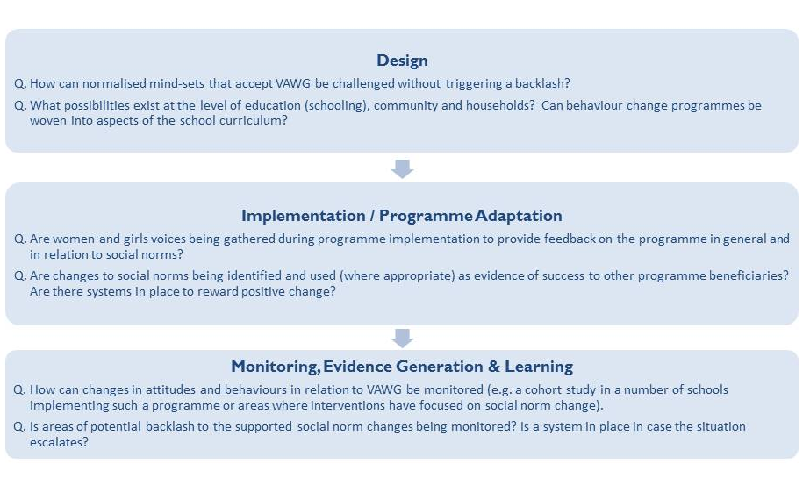

Increasing social perceptions of the benefits and value of girls and women being equal partners in societies free from VAWG.
If greater opportunities exist enhanced wellbeing (including a reduction of end to VAWG) can be seen than we can confidently say the value of women and girls has improved. Programmes need to make efforts to support the development of new opportunities for women in education and the workplace and build on networks already in existence. Ultimately this dimension will be achieved if the second has also been successful. This dimension at programme level might involve tapping into or capacity building at the level of women’s social movements and civil society organisations. If there are visible organisations advocating for women in public spaces this will likely help to promote the value and benefit of women’s full and equal participation in life. The barriers that may prevent this (e.g. VAWG) will need to be removed as part of this process.
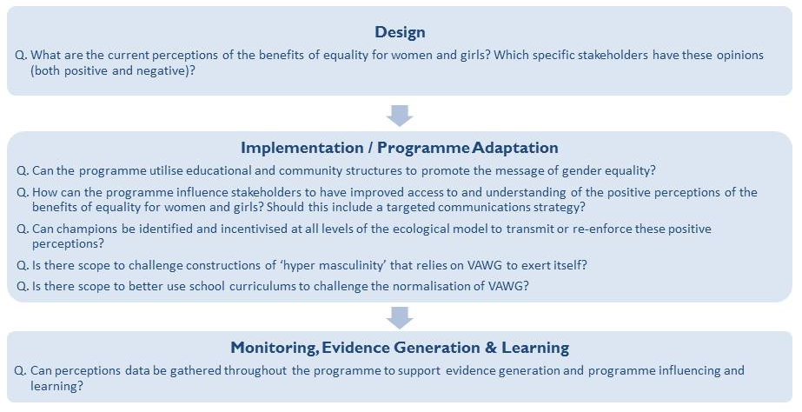

The VAWG Mainstreaming Framework feeds into the following sequence of theories:

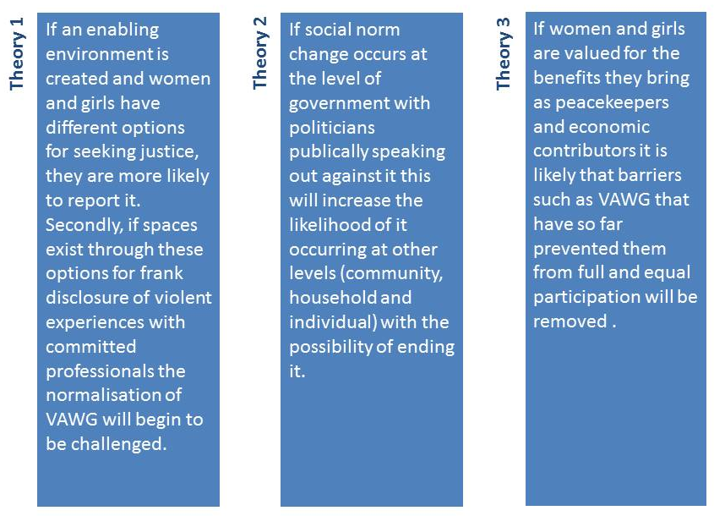

Final Comments
Whilst there are no magic solutions or blue print formulas to end VAWG we believe that adopting a systematic and evidence based approach such as that outlined above, as a starting point, will produce robust and sensitive programmes that represent a positive way forward in achieving SDG 5 but more importantly support the end to VAWG.
We believe this simplified VAWG framework to be a starting point for action and will look to improve and build on it through further evidence generation, gathering and analysis.

